Assignment 2: Introduction To Programming

Name: Harshal Atre Balkrishna

Roll NO. : A-76

I. Write a program to read the input and print the output as mentioned below.

Input: 25

1.1

Output: 25

1.2. Input: 5.3267

Output: 5.3267

1.3. Input: 5.3267

Output: 5.32

1.4. Input: 5664.57567456

Output: 5664.57

1.5. Input: 35345364

Output: 35345364 \* 35345364

I .6. Input & Output: Your name

1.7. Input & Output: S. V. National Institute of Technology, Surat

Answer:

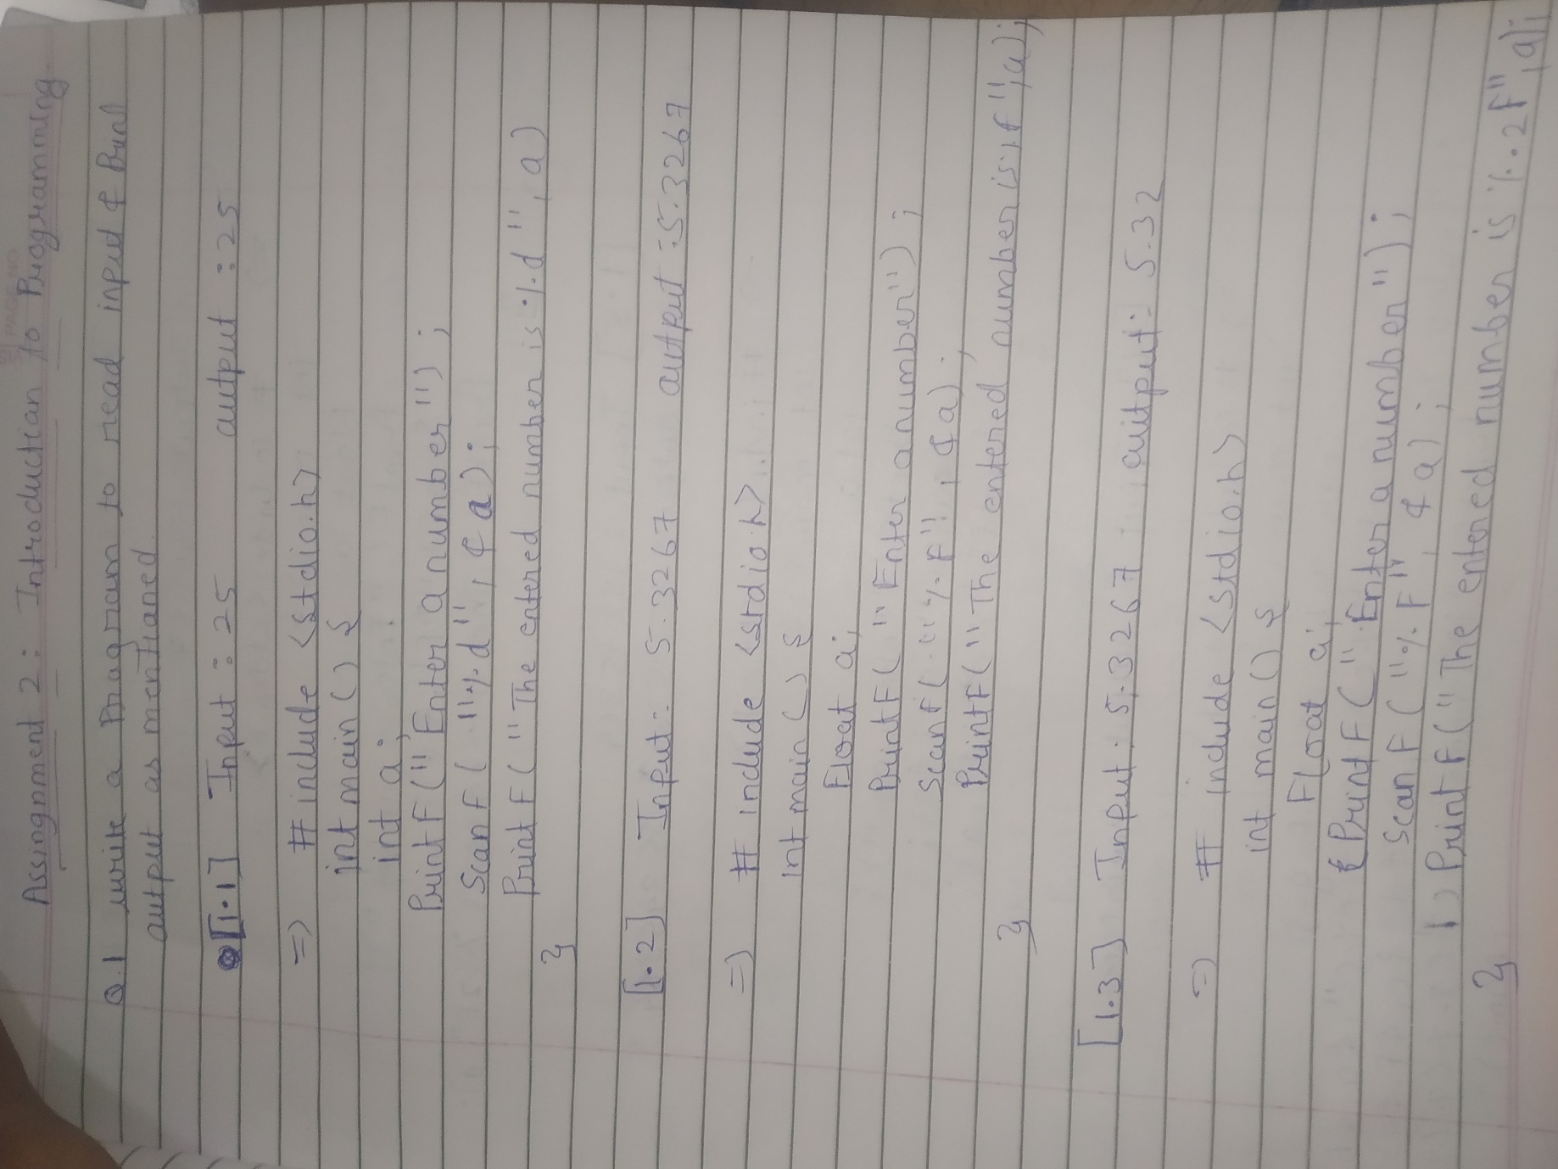

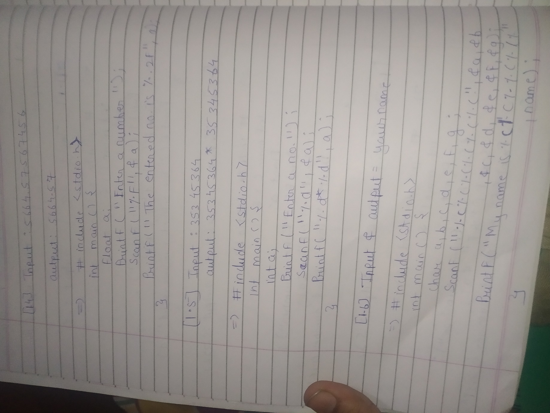

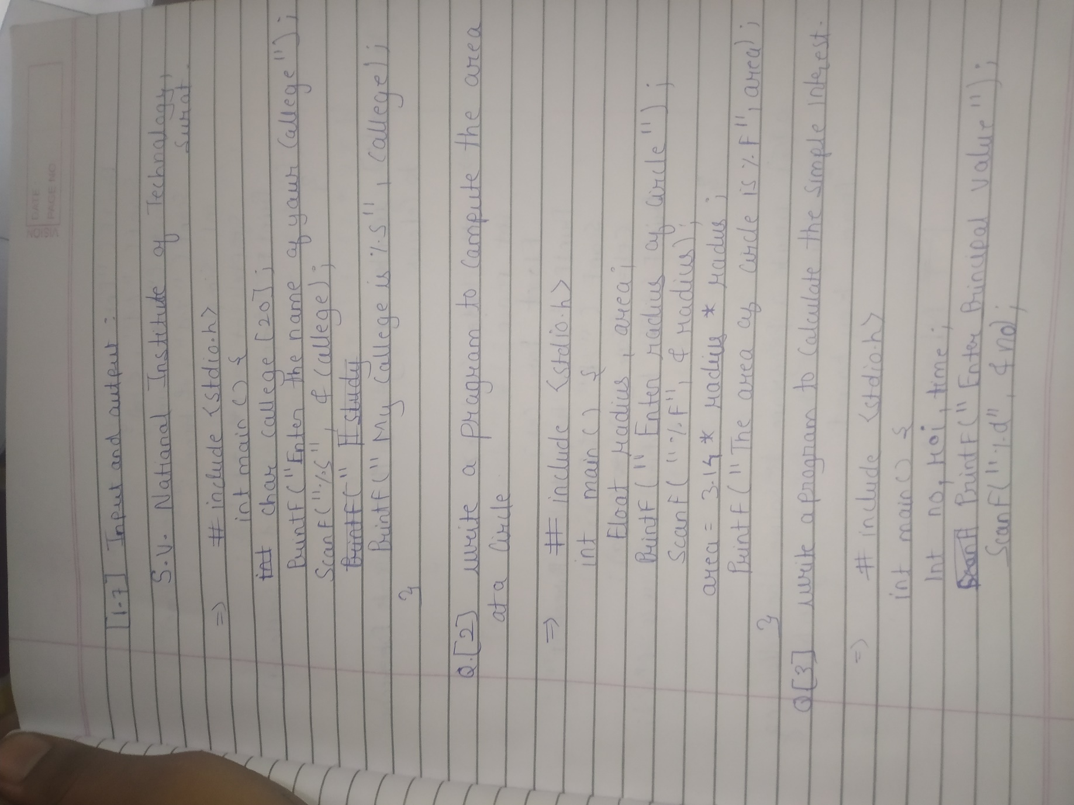

2. Write a program to compute the area of a circle.

Answer:



3. Write a program to calculate the simple interest.

Answer:

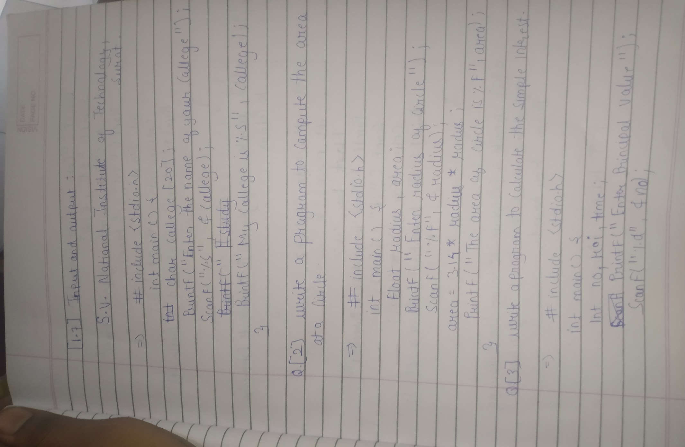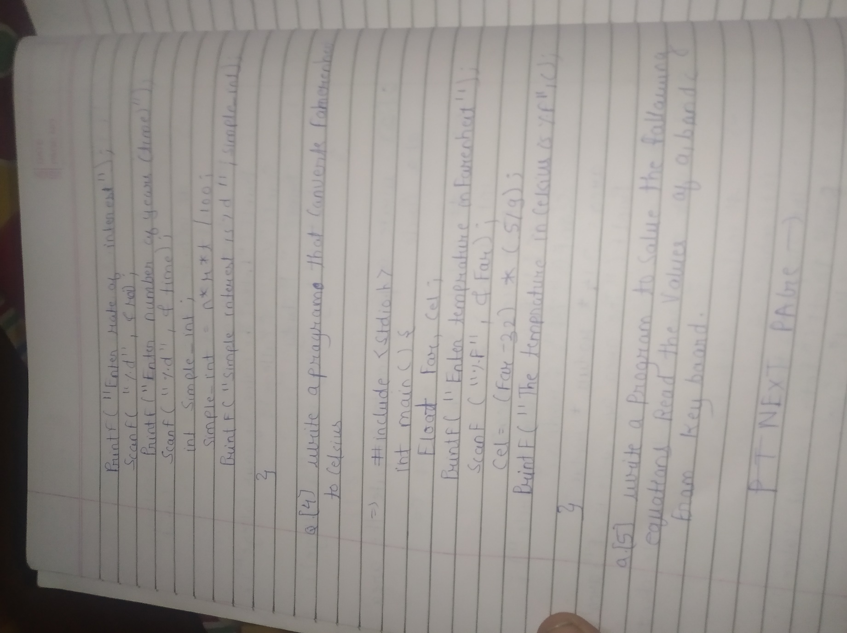

4. Write a program that converts Fahrenheit to Celsius.

Answer:



5. Write a program to solve the following equations. Read the values of a, b, and c from the keyboard ,

5.1 a^2 +2ab+b^2

5.2 a^2 -2ab+b^2

5.3. a^3+b^3+c^3-3abc

Answer:

‑‑‑‑‑‑